**Invoice Parsing program user guide**

# Installation steps:

There is no installation needed for this parser program, user only needs to create 4 folders and change the configuration file for the parser program. Below are 3 steps how to do this:

## Create folders for parsing program

*The parsing program* folder is used to stores code and configuration file. In this example it is saved in C drive and folder name is **ParsingPDF.**

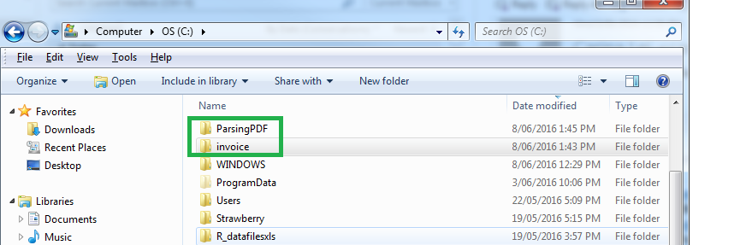

**Figure 1 folder structure for Demo**

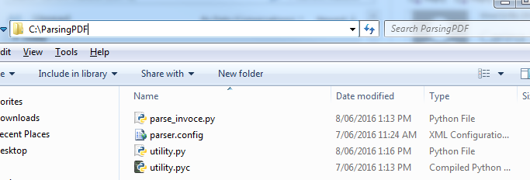

**Figure 2 content in program folder**

## Create working folders for the program

*Working* folder is used to store all the invoices and converted csv result. In this example it is saved in C drive as well, folder name is **invoice**. Under this folder, user needs to create 4 sub folders, the name for these folder needs to be exactly same as listed below (case sensitive):

*-working (stores all the invoice files need to convert to csv files)*

*-result (stores all the result for invoices file)*

*-history (store all the invoice txt files already converted successfully)*

*-error (stores all the invoice txt files that converted but the total converted invoice amount is not same found from invoice file)*

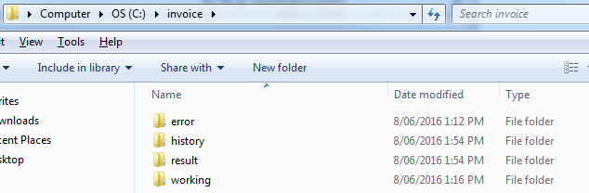

## Change the value of configuration file

The only changes needs to be done is to open parser.config file by Notepad and change the value of parameter ***Invoice_root_folder.*** The format is

Invoice_root_folder:**working folders name created in step b**

***Please note: Need to use symbol “\\” instead of “\”. As an example:***

***Invoice_root_folder is “c:\\invoice” instead of “c:\invoice”.***

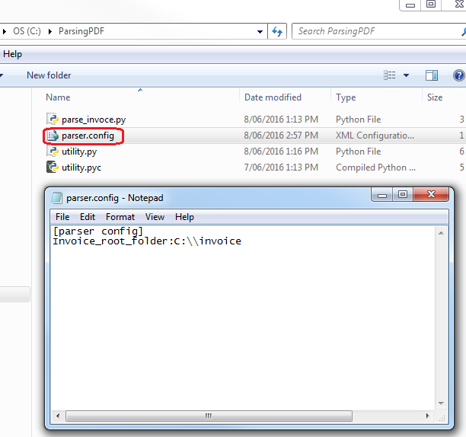

# How to use parsing program

## Run windows program “Command Prompt”

## Go to program installation folder by type: cd “parsing program installation folder”

***e.g cd c:\ParsingPDF***

1. Run the program by type: ***python parse_invoice.py***

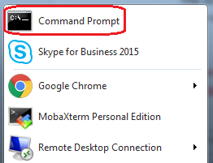 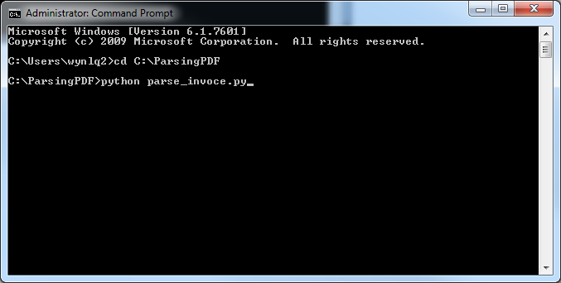

# Result of the Parsing program

The program will show conversion result for each invoice file, if the total converted invoice amount is same as Amount found from invoice file, the program treat the conversion finished successful, the csv invoice file will saved in “result ” folder, source invoice file will move from “working” folder to “history” folder.

If the total converted invoice amount is different from Amount found from invoice file, the program treat the conversion failed. However csv invoice result will still save in “result” folder, and source invoice file will move from “working” folder to “error” folder.

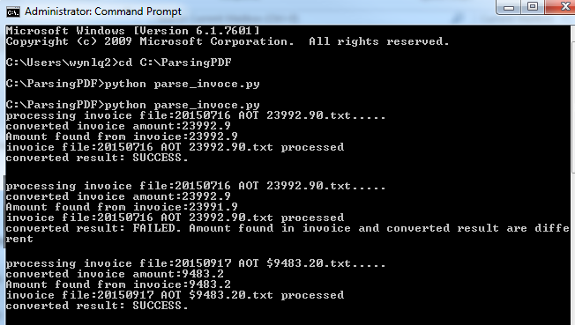

If the invoice file had been already processed successfully before, the program will ask user if this file needs to be reprocessed again. Please type ***yes*** in lower case if you want this to be re-run, all the other user type will treat as ignore:



If there is no invoice stored in “working” folder, the program will do nothing.

